Kyle Weng

IDS 126

Final Project Interim Results

Questions to answer

The below discussion (most of my interim work) concerns the question “**Which individual teams contribute the most to their alliances’ victories?**”. However, there are more specific questions I can ask regarding game-specific mechanics from each season (as an example, **“How important is a particular objective for an alliance’s score?”**). Depending on the scope of my data, I can also look into questions that aren’t regional/season-specific, such as **“How much do individual teams improve over time?”**.

Data sources

I’m still working on my data scraper to collect my own results in a useful format, but for now, I’m using some pre-compiled data from The Blue Alliance’s website. This data is pretty limited, however—it just contains alliance scores and the teams on each alliance for each match. For that reason, I’ve only picked one regional competition’s worth of data to analyze so far. I anticipate being able to look into other questions and refine my approach once I get my custom data.

What I’ve done so far

So far, I’ve examined the data from the 2018 FRC Las Vegas Regional. There are a lot of specific numbers I can plan to look at, but first I wanted to get a feel for the surface-level data—the scores of each match. The data was stored such that each row contained the following information for a single match: a) the three teams of the red alliance, b) the three teams of the blue alliance, c) the red alliance’s final score, and d) the blue alliance’s final score. I recoded the team information into an indicator variable (“frcX” for team X) for each team, where “1” indicated that they participated in a certain match and “0” otherwise. First, I wanted to see how well I could predict the results of a match given which teams were participating. For simplicity, I only examined red alliances and the corresponding scores first.

I tried fitting the red scores using all of the teams’ indicator variables as predictors. The only problem was that there were only 103 matches played at this regional. This is a fairly typical number, given that there were 44 teams competing. However, it’s pretty obvious that fitting 103 observations to 44 predictors wasn’t going to end well. I still wanted to see how that’d turn out. The poor fit was apparent and the standard errors were terrible (fig. 1). If I want to do a larger-scale approach like this, I’ll need to compile a lot more data from other regionals as well.

I tried the fit again, but instead of using all of the teams, I used five of them (fig. 2). The standard errors were less egregious, but the residual plot was still very poor (fig. 3). (I assume that the points that follow the vertical line at x = ~275 are from match results that none of the five teams played in.) This makes sense, as more teams than just these five played in these matches. There are predictors I haven’t included in the model, and I haven’t even considered interactions. There should be many interactions, as this game relies on teamwork—an alliance’s overall strategy will depend on the capabilities of the teams in that alliance, as well as those of the teams on the opposing alliance.

Seeing as how I’ve largely just been focusing on overall match scores (as opposed to specific game objectives), I thought it’d also be useful to make some exploratory graphs on the distribution of red alliance scores (fig. 4), the distribution of blue alliance scores (fig. 5), and the distribution of score differences (victory margins—fig. 6). This one is actually particularly interesting, since it indicates that the blue alliance won more matches than the red alliance. Optimally, this distribution would be closer to a normal one, but it seems as if stronger teams ended up more frequently on the blue alliance in matches. (Background information: in preliminary matches, which form the bulk of this data, teams are randomly assigned to either the blue or red alliance for ~10 matches.) This could incidentally be something worth briefly exploring: are teams really assigned with/against each other at random?

Data and model fits

See below for figures.

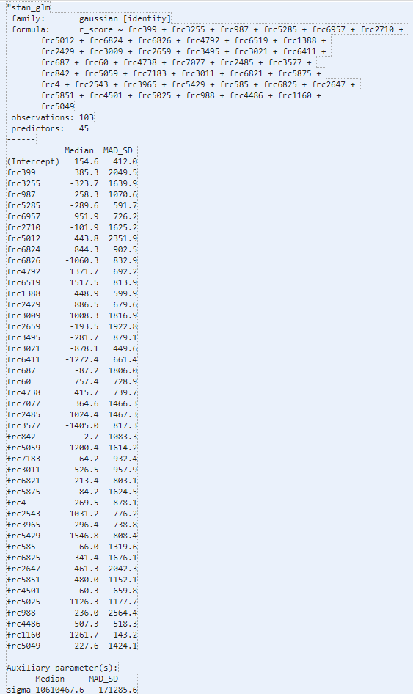

Figure 1. Fitting red alliance score data to every possible predictor.

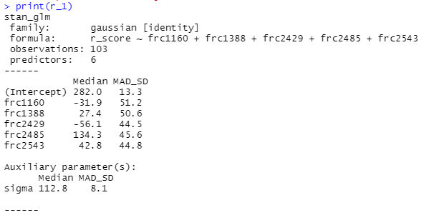

Figure 2. Fitting the red alliance score data to five predictors.

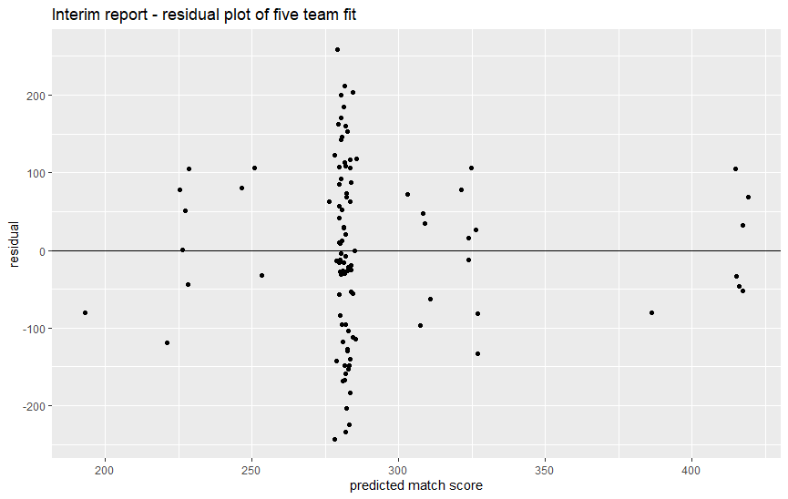

Figure 3. Residual plot for the model in fig. 2.

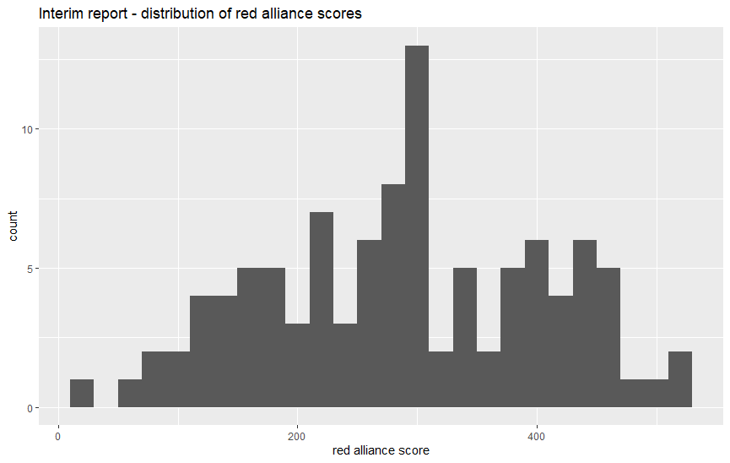

Figure 4. Histogram of red alliance scores.

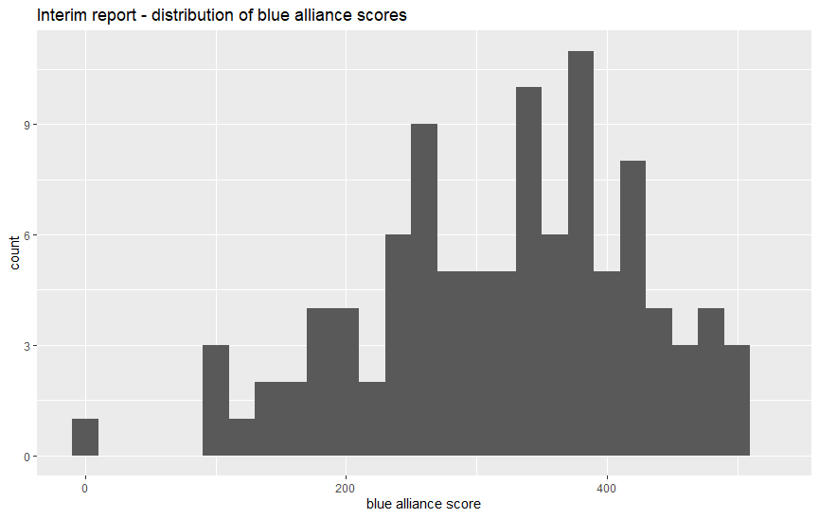

Figure 5. Histogram of blue alliance scores.

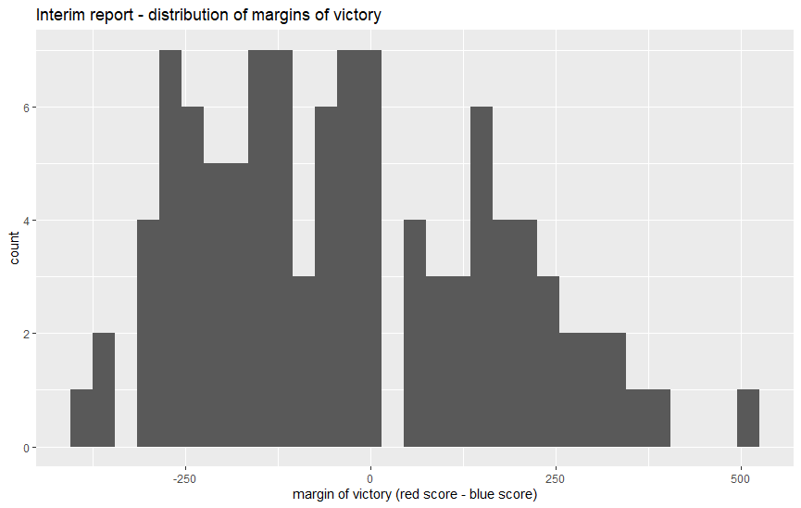

Figure 6. Histogram of victory margins.